Media Contact: Lora Ledermann, 303-523-3925
Lora@screamagency.com
NEWS RELEASE
(For Immediate Release)

Dr. Ryan Moroze Joins AllHealth Network as Chief Medical Officer
ENGLEWOOD, CO (April 15, 2020) — AllHealth Network, a nonprofit organization that has been providing mental health and substance use treatment to the South Denver metro area communities since 1955, is pleased to announce that Dr. Ryan Moroze has joined the organization as Chief Medical Officer.
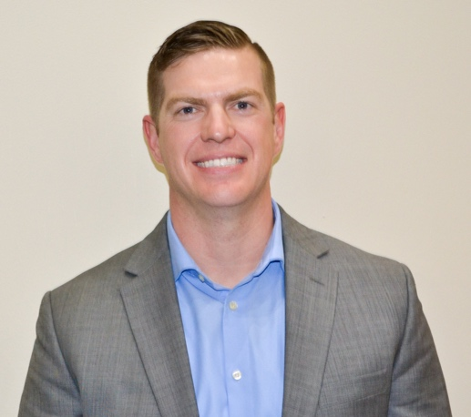
Dr. Moroze brings an extensive range of clinical mental health experience and leadership to this position. At AllHealth Network, Dr. Moroze will provide clinical care at several sites while providing medical leadership to all of AllHealth Network’s outpatient offices and the Acute Care Campus. Prior to joining AllHealth Network, Dr. Moroze served as the Vice Chair of Psychiatry and Addiction Services at West Pines Behavioral Health at Lutheran Medical Center for three years where he provided patient care in detoxification, inpatient, emergency department and consultative settings. He previously served as the Associate Director of Psychiatry Consultation/Liaison Services at Denver Health Medical Center. Dr. Moroze also served as President in 2019 for the Colorado Child and Adolescent Psychiatry Society (CCAPS) and previously was the CCAPS Secretary/Treasurer.
“We are delighted that Dr. Moroze has joined our AllHealth Network team,” said William Henricks, CEO and President of AllHealth Network. “His depth of clinical expertise in psychiatry and addiction services coupled with his leadership within the medical provider network will provide tremendous value for our team.”
- MORE -

A graduate of Regis University in Denver, Dr. Moroze attended medical school at the University of Colorado School of Medicine. He completed his internship in psychiatry at Duke University and his general psychiatry residency and child and adolescent psychiatry fellowship at the University of Colorado. He served as the Chief Child and Adolescent Psychiatry Fellow at Denver Health Medical Center during his fellowship. He is board certified in Adult and Child & Adolescent Psychiatry. He has previous experience in telepsychiatry, substance use treatment, emergency psychiatry, and integrated care.
“I’m thrilled to work with this talented team of leaders and providers,” said Dr. Moroze. “I’m looking forward to utilizing my skills to further improve provider engagement and the overall quality of care across the network. A great example of this is how we’ve all been working diligently to push our telehealth model out during this pandemic to reach the community in ways that we couldn’t support before.”
Dr. Moroze and his wife, Amber, have a 10 month old son, Liam. In his spare time, Dr. Moroze enjoys hiking, grilling and watching Duke Blue Devil basketball.

About AllHealth Network
AllHealth Network is your compassionate provider of mental health and substance use treatment, offering a full array of clinical services at 11 locations throughout the South Denver metro area. With over 200 clinical providers and more than 25 psychiatrists and nurse practitioners, AllHealth Network offers services from a caring team of clinicians who create personalized treatment plans to help clients thrive. For more information visit https://www.allhealthnetwork.org/.

###

